

HHS Accessibility Guide

This guide provides information and helpful links to assist in navigating accessibility standards for created content at LCC. For the purpose of this guide, accessibility is defined the inclusive design of documents (such as forms, fliers, handbooks, etc.) and digital content (such as files, emails, videos and web pages). Accessibility isn’t just for students but also for clinic guests and coworkers too. Materials intended to be shared with others must be made accessible.

Why it matters

Accessibility removes barriers for people with physical, visual, auditory, or cognitive disabilities, enabling independent access and interaction. Accessible design not only fosters independence and equality, but it also benefits the wider population, including aging individuals and people with situational limitations (for example trying to read a phone in bright sunlight). Accessibility isn’t just a good idea that LCC adopted to provide a more inclusive environment as certain types of content are now mandated by federal law.
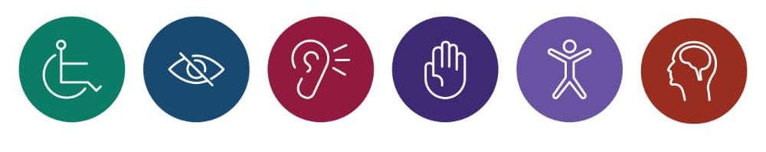
Title II of the Americans with Disabilities Act (ADA) requires state and local governments to ensure that their services, programs, and activities are accessible to people with disabilities. This includes services, programs, and activities that state and local governments offer online and through mobile apps. Examples of state and local governments include public schools, community colleges, and public universities.

LCC’s Accessibility Guidelines

LCC’s Accessibility Guidelines provide an explanation on how and why to fix different accessibility issues across various content types. Every employee is responsible for ensuring all documents created are accessible, including those made in programs not listed within the guidelines found on the LCC’s Accessibility Guidelines webpage.

TMS accessibility trainings
The Talent Management System offers several accessibility related trainings. Search “accessibility” to view and request trainings at any time.
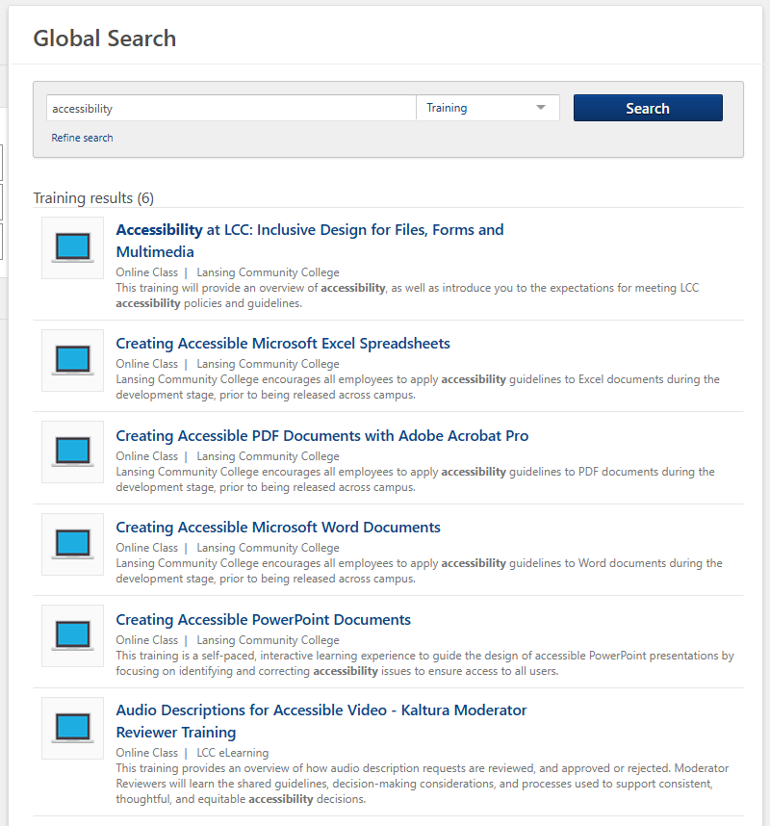

Accessibility in documents

There are multiple things to keep in mind when making a document accessible. A sans serif font, size and contrast are just a few examples of items you need to consider. Alt text for images, heading order, table design, and hyperlinks are also important.
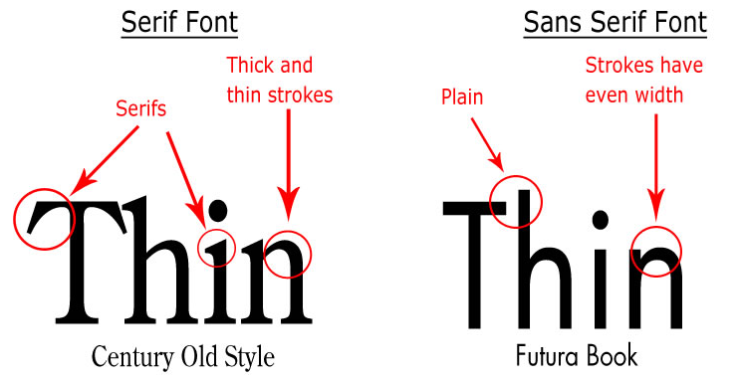
The Center for Teaching Excellence (CTE) has a series of guides to help cover all of the bases. Access to their guide titled Making Accessible Microsoft Word Documents is found on their Accessibility Tutorials webpage. If preferred there is a series of concise videos, organized by program type which can be found on the Accessibility Help Videos page.

Accessibility checking tools

Once the draft is complete, use the accessibility checkers to review the document for accessibility issues. Within Microsoft Word there is an accessibility checker under the Review tab. Click on “Check Accessibility” to have the program look for errors. The image on the right was taken of this document’s rough draft to show how alt text still needs to be added to make it more accessible.
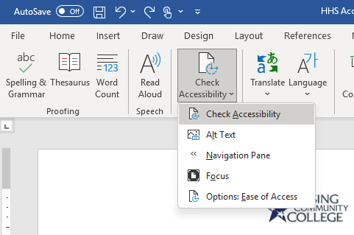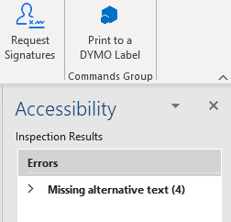
There is an additional accessibility checker found in the D2L home page. Uploading the document into the Ally Site can provide another way to check for errors. By clicking on the yellow gauge below, the program will provide greater detail on the issues to fix.
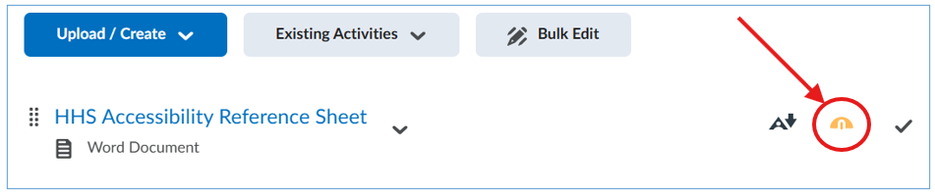
The accessibility checkers will not catch everything. Be sure to manually check for the following:
- Alt text descriptions match the images they describe
- Images are not composed of multiple parts
- Images have high contrast
- No word art is used
- Table layouts are structured with headers
- Proper ordered list structures are used (such as bullet points or numbers)
- Form fields are used for data entry, instead of continuously using underscore to create lines
  - To better understand why, try using the underscore to create a line followed by the “Read Aloud” function

Useful accessibility webpages

A list of accessibility webpages with embedded hyperlinks:
- Accessibility at LCC
- Accessibility Help Videos
- Accessibility Tutorials
- Accessibility Trainings
- Ally Accessibility Report
- D2L Course Design Accessibility
- External Accessibility Resources
  - Web AIM (Accessibility in Mind) A great external website for checking font contrast.

