- When to use Exception Time Entry
  - Grant related activities
  - BCI contracted trainings
  - Special Events Internal
  - Special Events External

- Exception Reporting Log
  - The hours recorded on an Exception Reporting Log must match the hours recorded on Exception Time Entry on a timesheet. Please review and confirm that the total hours on both entries are exactly the same.

- Enter Base Hours / FOAPAL Override
  - Log into mylcc.edu and click on ‘Work’ tab.
  - Timesheets are located under Time Reporting in the center of the webpage
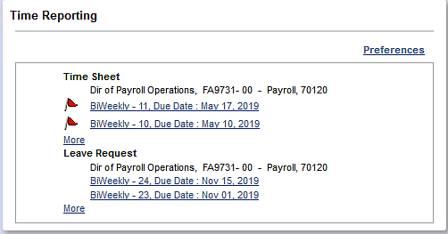
  - Click on appropriate timesheet pay period to begin entering time worked.
  - Click ‘Enter Hours’ on the appropriate earnings and date line. Base Hours must be enter to generate a paycheck.
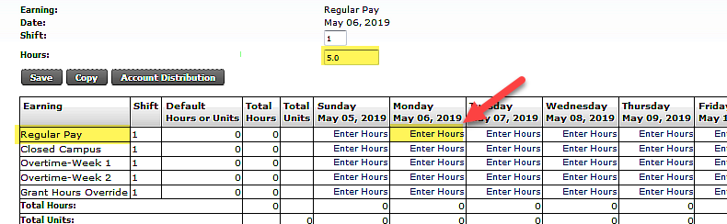
  - Enter the total hours worked for the day. Ex: 8a-12p = 4 hrs.

  - Click on ‘Account Distribution’.
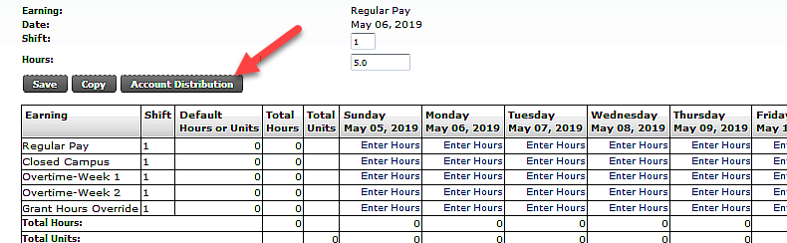
  - Review the Current Account Distribution.
    - If you want to override to a different FOAPAL, click on ‘Update’.
    - If not, click on ‘Previous Menu’.
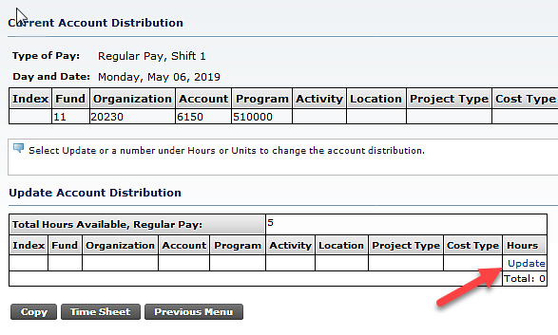
  - Enter the Exception Time Override
    - Enter hours to be charged to Exception Time FOAPAL. Must be equal to or less than base hours entered.
    - Enter Index Code or FOAPAL. Do not enter both.
      - Index Code – enter index code and click ‘Default from Index’.
OR
      - FOAPAL – enter Fund, Organization, Account, Program, and/or Activity.
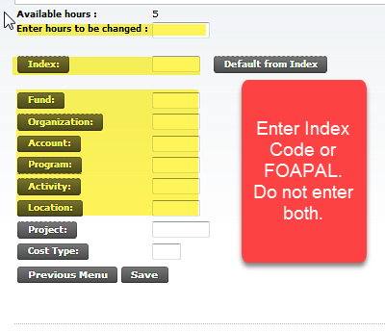
  - Click ‘Save’.
  - If you have more than one (1) Index/FOAPAL for a particular day: Enter the hours and Index/FOAPAL on separate Account Distribution lines by clicking ‘Update’ and entering another line. Remember the total of all override Account Distributions cannot exceed the total hours on the base hours (Regular, Lab, etc.).
  - Optional: Click ‘Copy’ to copy the same data to multiple days on the timesheet.
    - Select the days that this information should be copied to.
    - Click ‘Copy’
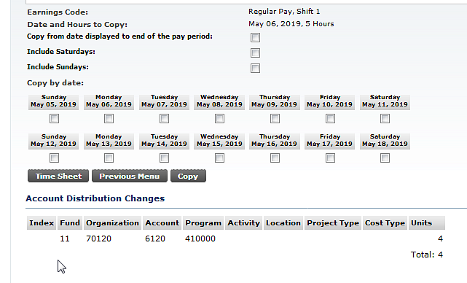
  - Click ‘Time Sheet’
  - A double asterisk (**) will appear next to the hours on each day that has exception time reporting with an account distribution override.
  - Repeat steps d – j to enter as many times as needed.
  - Review timesheet and ‘Submit for ‘Approval’.

