GET FAMILIAR WITH THE STUDENT INTERFACE
Select Student Interface (https://lcc-advocate.symplicity.com)
Select “Student”

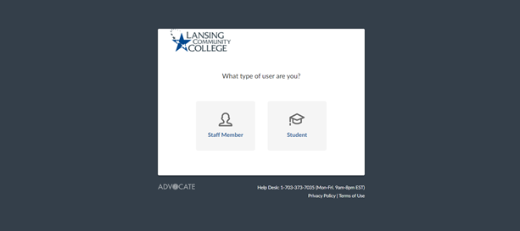

Sign in with your LCC email (USERNAME@mail.lcc.edu)
If you have not set up your account select “Forgot Password”, which will allow you to create a password for your, already enabled account. You can also select this if you have indeed forgot your password. Any further issues, contact our office 517-483-1261 or lcc-osc@lcc.edu.
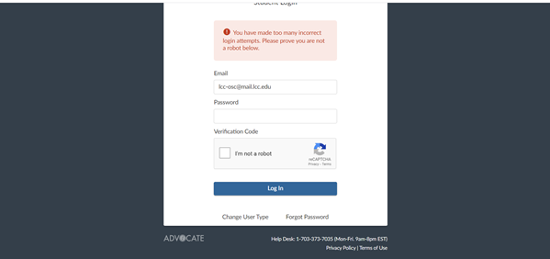

HOME SCREEN AND LETTERS:
Once you have signed in, this is what your Student Interface home screen should look like
Under “Letters” you can view all the conduct related letters our office has sent you.
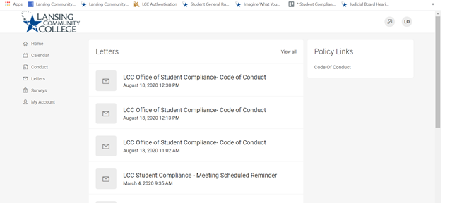

CONDUCT:
By selecting “Conduct” on the left hand side of the screen, you will be taken to the conduct page. This will show your upcoming hearings, sanctions, sanction deadlines, as well as any appeals on file.
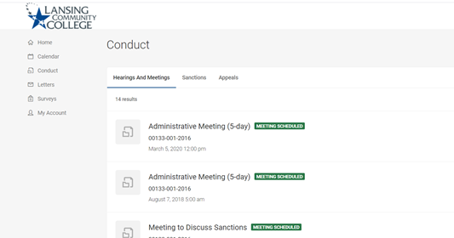

UPLOADING SANCTIONS:
By selecting “Sanctions” you have the ability to review all sanction details, deadlines as well as uploaded completed sanction assignments, right to the case.
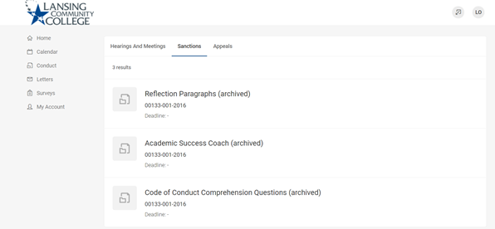

You can upload documents by selecting the sanction that applies. Select upload document on the left and side of the screen. It is important to note you can only upload one sanction at a time and the document must be uploaded to the sanction that is specific to that assignment
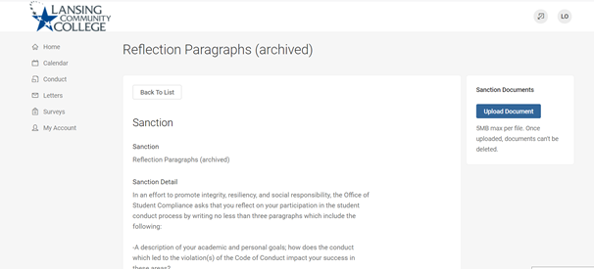

PERSONAL INFORMATION:
You can view your personal information, but you cannot make changes to it. If something does not look correct, please contact our office.
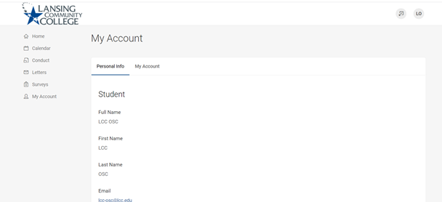

CHANGE YOUR PASSWORD:
You can change your password by clicking “My Account” on the left hand side of the screen and then “My Account” at the top of the screen. 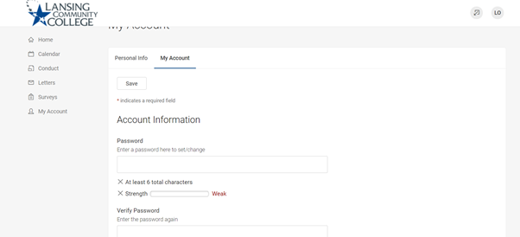

SCHEDULED MEETINGS:
Under calendar, you can see any upcoming meetings or Student Conduct Hearings that you have scheduled with our office.
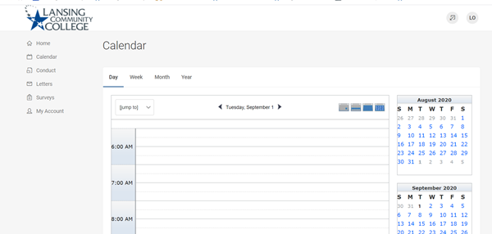

SURVEYS:
The Survey section is still under construction. Our hope is to move all Student Code of Conduct questions here, as those are often, assigned as a sanction to students.
