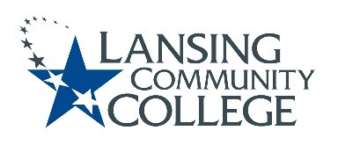

Agenda

Human Subjects Institutional Review Board (HSIRB)
October 13, 2023 from 9:10 – 10am, HHS 104 with Webex Guest Option

Committee Members:
Patti Ayers, Matthew Fall, Kali Majumdar, Patricia McKay, James Owens, and Melinda Wilson.

Alternate:
Heather Bunce

Community Member:
Louise Simon

Approval of April 28, 2023 Minutes.

Submission: Continuing Review Form
Title: Cardio Exercise and Student Success: Phase 1
Principal Investigators: Marianne Croze, Karen Hicks, Tiller Landick, and Amy Stoakes
Lansing Community College Employees
Review packet sent to group on 9/18/23 and again in meeting packet 9/29/23
- Previous continuation approved 10/14/2022
- Researcher(s) will attend meeting via Webex or F2F.

Research Review
Title: Understanding Academic Coaching at Community Colleges, A Multi-Case Study
Principal researcher, Doctoral Candidate Stephanie Joiner, Kansas State University
Review packet sent to group on 9/27/23 and again in meeting packet 9/29/23
- Researcher will attend meeting via Webex.

Review of Project Log
- Standing Agenda Item
  - Quick overview of status of active projects and items that came in between meetings

Action Items.

Future Agenda Items.

Other items/next meeting/meeting adjourned.
  - Next meeting November 10, 2023
Lansing Community College is an equal opportunity, educational institution/employer.

