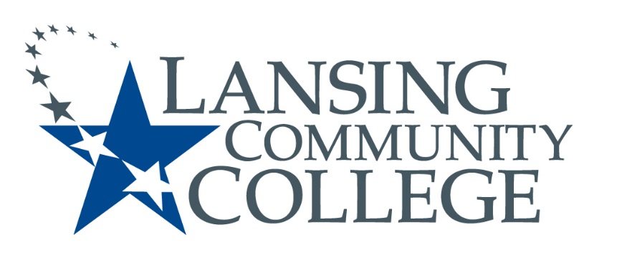
Public Meeting Notice

LANSING COMMUNITY COLLEGE
Human Subjects Institutional Review Board Meeting
Friday, May 6, 2022
419 North Washington Square Lansing, MI 48933
Arts and Sciences Building, Room 1120
2:40pm – 3:30pm

For more information, please go to IRB Consumer information (https://lcc.edu/consumer-information/institutional-review-board.html) or contact Terri Christian at 517-483-1123

---
Lansing Community College is an equal opportunity educational institution/employer. Lansing Community College programs and activities are open for all persons regardless of race, color, sex, age, religion, national origin, creed, ancestry, height, weight, sexual orientation, gender identity, gender expression, disability, familial status, marital status, military status, veteran’s status, or other status as protected by law, or genetic information.

