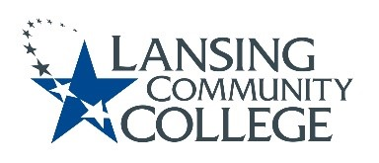

Agenda
Human Subjects Institutional Review Board (HSIRB)
March 4, 2022 from 11:10am – 12pm, A&S 1120 with Webex Guest Option

Committee Members:
Patricia Ayers, Matthew Fall, Kali Majumdar, Patricia McKay, James Owens, and Melinda Wilson

Alternate:
Vacant

Community Member:
Renee Brown

Guest
Researcher Dr. Lee Eshelman

Research Review
Title: Intersections of Sexual Victimization and Racism-Related Stress on Mental Health and Resilience among Black Women
Researcher: Dr. Lee Eshelman, Department of Psychology, University of Detroit Mercy
Proposal Packet sent to members on 2/25/22

Approval of the November 12, 2021 Minutes.

Action Items.

Future Agenda Items.

Other items/next meeting/meeting adjourned.
  - Next meeting is scheduled April 1, 2022, 11:10am-12pm A&S 1120 with Webex Option

Lansing Community College is an equal opportunity, educational institution/employer.

