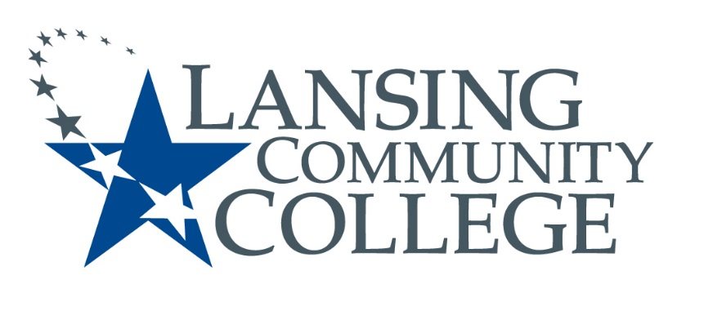
Public Meeting Notice

LANSING COMMUNITY COLLEGE
Human Subjects Institutional Review Board Meeting
Friday, September 3, 2021
610 N. Capitol Avenue, Lansing, MI 48933
Administration Building, Room 200
From 11am – 12pm

Also available via Webex
Please contact Terri Christian at christt4@star.lcc.edu to receive a link or call in number to participate virtually.

For more information, please go to IRB Consumer information (https://lcc.edu/consumer-information/institutional-review-board.html) or contact Terri Christian at 517-483-1123

Lansing Community College is an equal opportunity educational institution/employer. Lansing Community College programs and activities are open for all persons regardless of race, color, sex, age, religion, national origin, creed, ancestry, height, weight, sexual orientation, gender identity, gender expression, disability, familial status, marital status, military status, veteran’s status, or other status as protected by law, or genetic information.

