Blue/Explorance FAQs
Last updated Spring 2021

FAQs
- (note to developer: please use bullet as expand/collapse for each question)

- How do I access my course evaluations?
There are multiple ways to access your Blue course evaluations.

Access through email
An email is sent to you to announce a course evaluation is open for your section(s). You will receive one email that will include links for each of your sections and courses. The email is sent based on the timeline of the course. See the Important Dates table to identify when your course evaluation(s) is activated.

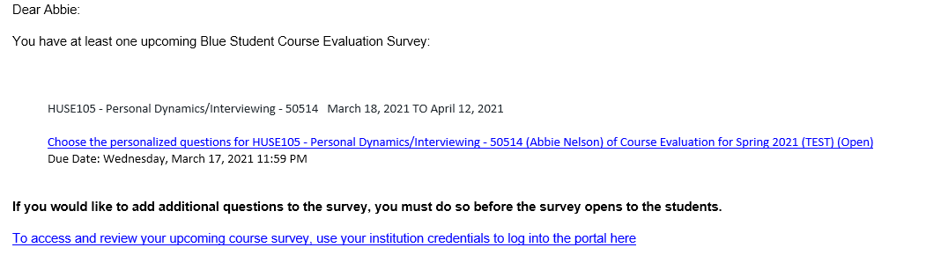
Access the Blue/Explorance system directly from myLCC
  - Log into myLCC
  - Open the Work tab
  - Click the Blue/Explorance link located in the Employee eToolbox under Faculty Services
  - Log into Blue/Explorance using your LCC user ID and password
  - Access course evaluation forms from your dashboard

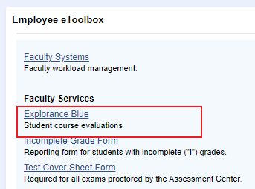

Access through D2L
- Once in D2L Click on the Course Evaluation Link in your upper menu choices
- You will be taken to your list of tasks, such as personalizing your evaluation questions or reviewing reports, and can click those to access that task directly
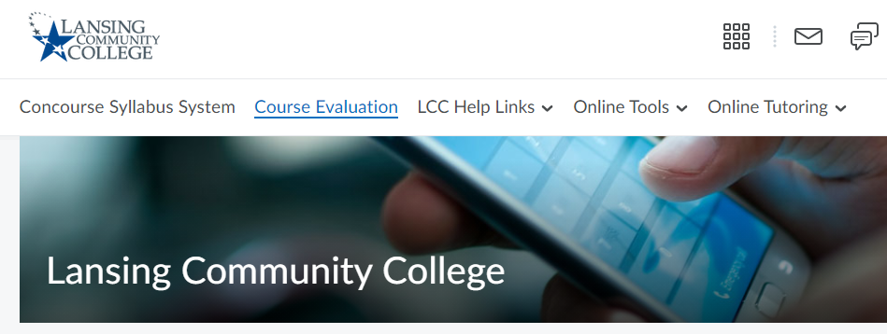

Access through Pop-ups
- When you log into D2L open task reminders will pop up on your screen
- You can hit “remind me later” or click on the link to be taken directly to that task
- Once the open task has been completed, or the due date has passed, the reminders will no longer pop up on your screen
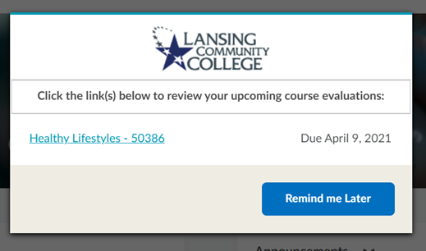

- How do I add personalized questions to my course evaluation form?
Faculty can add customized questions to the course evaluation form by selecting from a bank of questions or by adding free form questions.

Selecting from a bank of questions

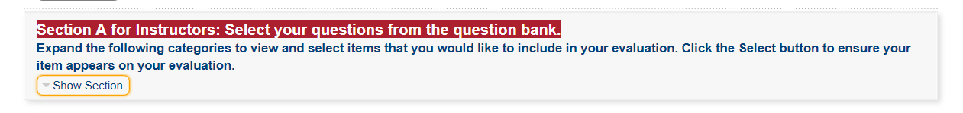

- Click Show Section to preview the question bank
- Click Select to add the question to your student survey or deselect to remove it from your student survey
- If a Likert scale question was selected, identify the Likert scale response options you’d like to use. Selected open-ended questions use an essay response.
- Click Update once you’ve selected the questions you’d like to include
- You can select as many questions as you like, however, use caution when considering the overall length of the survey to the student.

Add free-form questions
- Click Show Section to show question-type options
- You can add Likert-scale questions or open comment questions. Likert-scale questions have 2 options of responses (i.e. frequency and agreement). You can add up to 6 Likert scale questions (up to 3 using the Likert agreement scale and up to 3 using the Likert frequency scale). You can add up to 3 open comment type questions.
- Select the first question type you would like to use
- If Likert scale type is selected, select the Likert scale you would like to use for your question
- Input your free-form question
- Click Update once your questions are added
- You can add up to a total of 9 additional questions, however, use caution when considering the overall length of the survey to the student.

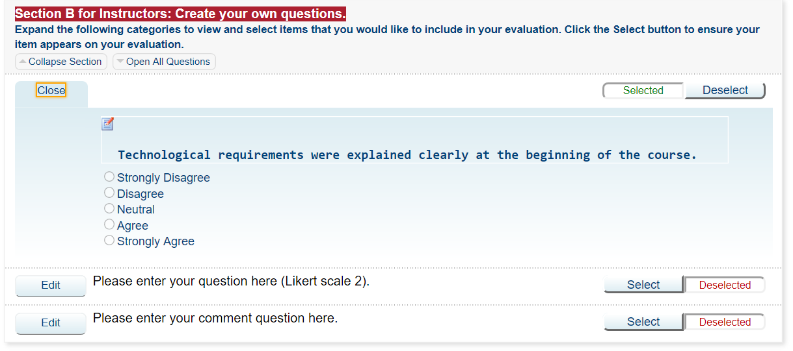
- When can I make changes to my course evaluation questions?
The start date and end date of your course determines the activation date of your course evaluation form.
Length of Semester | Course Evaluation Activation Date | Last day to Evaluate Courses | Adding Questions Cut-Off Date
16-week | 30 days prior to last course date | 11:59pm on the last day of the class | Up to day before course evaluation goes live to students in your course
14-week | 25 days prior to last course date | Same as 16-week | Same as 16-week
8-week | 20 days prior to last course date | Same as 16-week | Same as 16-week

- How do I access and view reports?
Coming soon.

- How do I increase response rates?
Research and faculty feedback show faculty can influence student response rates by: monitoring, creating value, and communicating
.
Monitoring: Real time monitoring in Blue gives faculty the ability to monitor the response rates of students in real time.
“ When the course evaluation went live, I reminded my students that they were available. The next week I asked them to complete it. I made a comment like, ‘Looks like 10 of you (although I don’t know which 10) haven’t yet filled out the course evaluation. Please make sure to do that!’”
– Christopher Greene-Szmadzinski, Sign Language, 90% response rate, fall 2015

Creating Value: Let students know how important the course evaluation form is to you and how you plan to use the feedback to make improvements to the course.
“ We met with the whole class and expressed to them the importance of their feedback. We told them that their feedback is used to help us to continue to use what is working, improve areas that need improvement, and eliminate things that are not working for students… We are always striving to create a positive and beneficial learning environment for our students and some of the best curriculum changes we have made have come directly from student evaluations.”
– Betsy Burger, Dental Hygiene, 75% response rate, fall 2015

Communicating: Keep students up to date on how you are following the response rates, the importance of the evaluation, and how the feedback they provide is used to make improvements for the benefit of all students.

Additionally, if possible to do in your course, In-Class Capture, is also a proven way to increase student response rates.
“ I gave students time in class to complete the evaluations on their smart phones as well as demonstrated how to access them.” – Catherine Griffin, Math, 76% response rate, fall 2015

- Who do I contact for help or more information?

Center for Data Science (CDS)
Lcc-cds@star.lcc.edu
517-483-1123

Center for Teaching Excellence (CTE)
cte@star.lcc.edu
517-483-1680

Informational technology Services (ITS)
Help Desk at lcc1@star.lcc.edu
517-483-2100

Committee for Assessing Student Learning (CASL)
Tim Deines, Chair
deinest@star.lcc.edu
517-483-1040

