Accessing Course Evaluation Forms
Our Student Course Evaluation vendor, Explorance Blue (Blue), has created a dynamic system to help students, faculty, administrators, and support staff access evaluation materials. This system requires an LCC login with LCC ID and password. Logging in will allow Blue to send you to your own unique homepage.

This means you will only see items pertaining to your courses, tasks, reports, and faculty dashboard (where appropriate). Each user group will see a different home page layout, which is helpful for getting quick access to the information you care about, but can be confusing when talking with supervisors or students.

All items in Blue are accessible using computers, tablets or mobile devices. The dynamic screen will adjust to fit your screen size. Blue works with most browsers, but if you have trouble try using Google Chrome.

There are multiple ways to access your course evaluation forms from Blue:
- Access through myLCC
- Access through D2L
- Access directly from web
- Access through email links

Your Blue Homepage
Your Blue homepage is the central location where you will access your tasks, reports, and faculty dashboard. It will look similar to the following image.
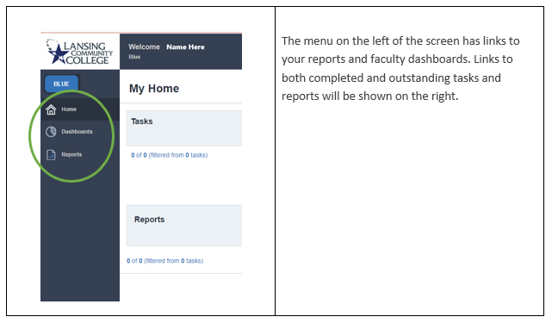

Accessing Blue Homepage through MyLCC
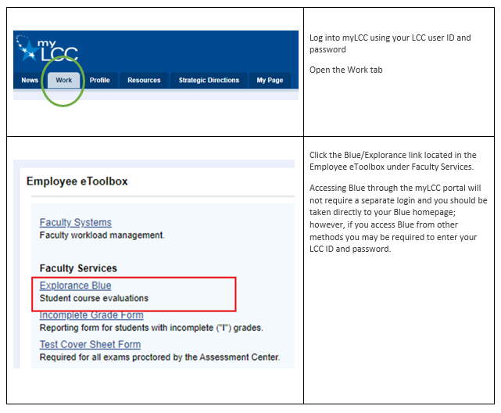

Accessing Blue Homepage Using D2L
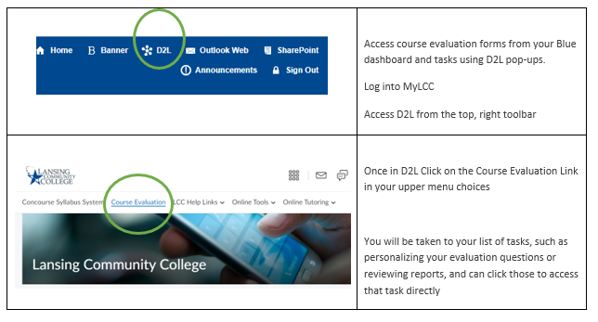

Accessing Tasks Using D2L Pop-Up
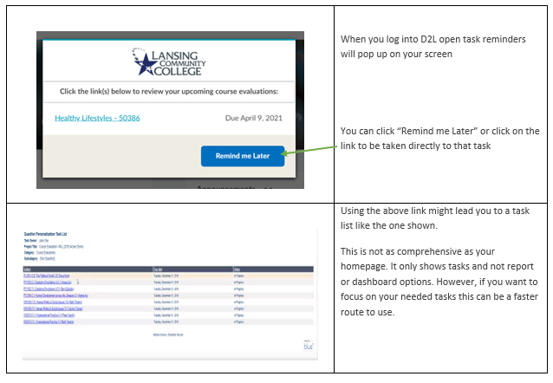

Accessing Blue Homepage Directly From the Web
Note regarding required LCC user ID and password
Logging into myLCC or D2L requires your user ID and password and you are not required to re-enter it when using Blue. However, if you access Blue from the web, or as described below using email links, you may be required to enter your user ID and password to gain access. If you have already logged into myLCC, or D2L, and still have that running you will not be required to login again. If you have not yet opened an LCC application then you will get the normal LCC login screen.

You can bookmark the following email address to take you directly to Blue when on the web.
https://lcc.bluera.com/lcc

Accessing Blue Homepage and Tasks With links From Emails
In the course of a semester you will be sent several emails from Blue. Some of them will take you to your homepage and some will take you to specific tasks or reports. Here are a few sample emails to show you what to expect.

The following two emails take you directly to a task list.
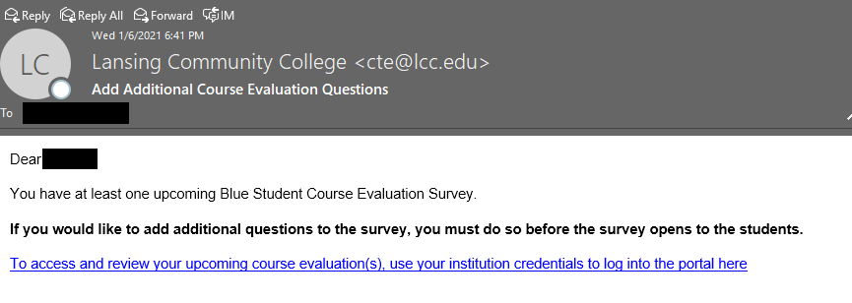

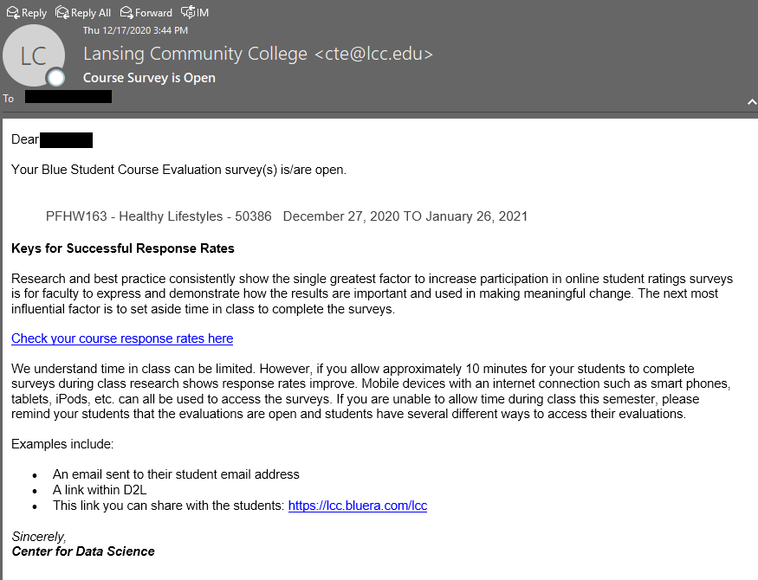
This email has a choice of going to a specific task list or your homepage:
