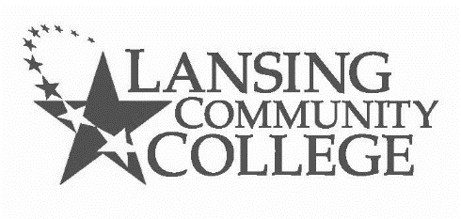
MTA Course Substitution Request

Section I: Student
Please complete and submit this request to LCC Academic Affairs Office, Administration Building, Room 201, 610 N. Capitol Avenue, Lansing, MI 48933, or via email to LCC-Academic-Affairs@lcc.edu.
Name: |  |  |  | LCC email: | @mail.lcc.edu
Student Number: |  |  |  | Phone Number:
Street Address:
City: |  | State: |  |  | Zip:
Would you prefer to receive a decision  notification via: |  |  |  | - U.S. mail |  | - LCC email
If via email, please be sure the email address above is your correct LCC email.
Is this request being submitted for the purpose of having “MTA Satisfied” indicated on your transcript?
- Yes ☐ No
Program/Major Name:
Program/Major Code: |  |  | Year of Curriculum Guide:
I am requesting that the
following course(s):
Taken at this institution (if
other than LCC):
Fulfill the MTA requirement in the following areas (check which ):
☐ | English Composition
☐ | English Composition (second course) or Communications
☐ | Humanities and Fine Arts
☐ | Mathematics
☐ | Natural Sciences
☐ | Social Science
I am requesting this substitution for the following reason(s):
Attach pertinent evidence/documents (e.g., course description or syllabus) supporting this request.
Student Signature: |  |  |  |  | Date:

Section II: Academic Affairs
Provost or Designee Printed Name:
 | - Approve
 | - Do Not Approve
Provide reason for approval/denial of this course substitution:
Signature of the Provost or Designee: |  |  | Date:
Final decision notifications sent by the Academic Affairs Office to:
 | - Student
 | - Advisor
 | - Registrar
Revised: 2022.01.25

