Lansing Community College Youth Program
Description of 2021 Summer Classes
Location: Livingston County Campus
402 Wright Road, Howell, MI

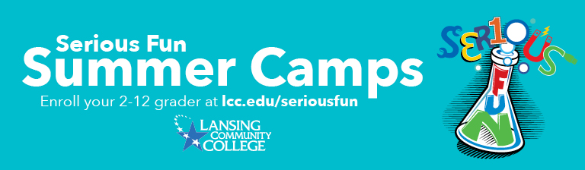
Please note that CDC guidelines (face cover and physical distancing) will be required for face-to-face classes this summer.

Classes are available to students going into 2nd-12th grades.

Classes start July 12th and July 19th
Monday-Thursday
Face-to-face-morning (AM) classes are 9:00am-12:00noon
Face-to-face afternoon (PM) classes are 1:00pm-4:00pm
Scholarships
Limited Scholarships are available to students who qualify (income-based). Contact the Youth Program Office at 517-483-1415 for more information.

More Information
visit our website at Livingston County Campus
contact us by email at lifelong@lcc.edu
call our Youth Program Office at 517-483-1415

Livingston County Center Face-to-Face Classes:

2nd-3rd Grade classes

Beginning Robotics 2nd-3rd Grade 07/12/21-07/15/21 1:00-4:00 pm
Younger kids can do robots too! Sphero robotics is a fun, hands-on way for your child to learn the basics of controlling and programming a robot. Easily controlled with provided iPads your child will be introduced to the exciting field of robotics!
REGISTER NOW

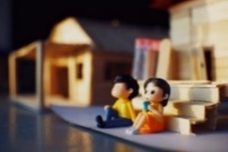

Brickmaster Story Builder 2nd-3rd Grade 07/19/21-07/22/21 9:00-12:00 pm
Create your own movie using stop-motion technology! Do you like to build stories on paper and with props? Would you like to try your hand at directing your own movie? Use building blocks, mini-figures and storyboards to create your own story. Using stop-motion technology and imagination, you can make your vision into a movie!
REGISTER NOW

Imagination Art 2nd-3rd Grade 07/19/21-07/22/21 1:00-4:00 pm
Explore your inner Picasso! Demonstrate your creative side by having fun sculpting with clay, painting on real canvas, learning about some famous artists and taking a turn at creating some of your very own Pop Art! You decide what you create and have fun and learn while you are at it! Students will love all of the possibilities as they create their very own masterpieces!
REGISTER NOW

4th-5th Grade Classes

Art-Explore Paint Mediums 4th-5th Grade 07/19/21-07/22/21 9:00-12:00 pm
Sparkle, splash and create through painting, making plaster masks, trying different art mediums understanding where art can take you. You’ll learn how some famous artists began, just like you. You’ll have a blast showing off your grand skills!
REGISTER NOW

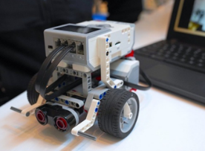

Battling Robots, Jr. 4th-5th Grade 07/12/21-07/15/21 9:00-12:00 pm
Think you can create the undefeated battlebot? Bring it! Whether you have never built a Lego Robot before, or if you are an undisputed master, you are welcome to this class! You will learn to design and build your own Lego EV3 robots limited only by your imagination!
REGISTER NOW

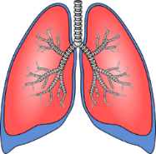

Hey Doctor! Anatomy 4th-5th Grade 07/12/21-07/15/21 1:00-4:00 pm
Are you curious about why your lungs inflate and deflate? Are you more intrigued than grossed out by blood? We will be taking a look at important systems in our body, the parts that make them up and how they work! Here we will investigate the workings of the heart, lungs, brain and bones. We will look at real bones, explore how our heart pumps and build a model of our lungs.
REGISTER NOW

4th-5th Grade classes, continued

Scripting Graphic Novels 4th-5th Grade 07/19/21-07/22/21 1:00-4:00 pm
Do you love animation, graphic novels and adventure? Every video game, movie and TV series begins with a great story idea. Learn how to draw and write graphic novels inspired by your favorite games, movies and TV adventures; or create your own magic.
REGISTER NOW

STEM Sports 4th-5th Grade 07/12/21-07/15/21 9:00-12:00 pm
Using science, technology, engineering, and math skills students will build a series of sports structures such as designing a basketball hoop and catapult, launching mini arrows in an archery contest, sailing a wooden boat, building a parachute, and make a big splash in a diving contest! Students can compete against each other for top honors or just have fun building.
REGISTER NOW

6th-8th Grade Classes

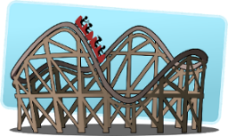

3D Theme Park Fun 6th-8th Grade 07/12/21-07/15/21 9:00-12:00 pm
Do you enjoy the thrill of a roller coaster? How steep of a slope will it take for you to scream? Using Minecraft education software, design and build a unique theme park. In this class you will use geometry, fractions, volume, area, perimeter and conversions to build the ultimate theme park. Your only limitation is your own imagination. Are you up to the challenge?
REGISTER NOW

Astronomy: Race to Space! 6th-8th Grade 07/12/21-07/15/21 9:00-12:00 pm
Do you ever look up at the sky and wonder what lies beyond our clouds? Well here is your chance to learn more! We will be learning about rockets, our moon, the stars, constellations and beyond! Students will work with hands-on projects, learn about our future on Mars, and leave being able to discuss what they see in the sky – whether day or night!
REGISTER NOW

Battling Robots, Sr. 6th-8th Grade 07/19/21-07/22/21 1:00-4:00 pm
Want to create the ultimate battlebot? Bring it on! Whether you have never built a Lego Robot before, or if you are an undisputed master, you are welcome to this class! You will learn to design and build your own Lego EV3 robots limited only by your imagination!
REGISTER NOW

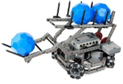
Battling Robots VEX IQ 6th-8th Grade 07/12/21-07/15/21 1:00-4:00 pm
Want to build your own robot? This hands-on class will teach students how to build, program, and test their device using real-life robotics technology. Students will use computer science, technology, and engineering with this hands-on VEX IQ platform. Students are encouraged to brainstorm in order to find creative solutions to problems and then develop them through a process of selecting, building, testing and evaluating. Robots will compete with each other throughout the class.
REGISTER NOW

Online Classes

App Attack! (Black Rocket) Ages 8-11 and 11-14 Online
Using a specialized app & game development tool, students will explore the world of web-based (HTML5) mobile apps. In addition to learning the basics of mobile app design and game development, you will also see firsthand how the world of App publishing functions. Student-created apps will be accessible on a private site and can be played on any mobile device or computer. No prior experience is necessary and students do not need to own a smartphone or tablet to take the class.
REGISTER NOW

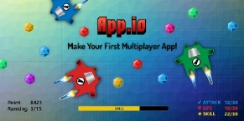

App.IO: Make Your First Multiplayer App! (Black Rocket) Ages 8-11 and 11-14 Online
The hottest new Apps are IO apps! If your child likes to play Agar.io or Slither.io they will love this class! Become the creator of the next viral web app and share with family and friends! In this class, you will explore the most popular .IO apps, design your own multiplayer experience and learn how to code your own app. Students will work in pairs or teams for most of the program.
REGISTER NOW

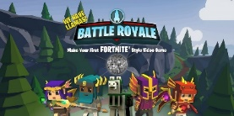

Battle Royale: Make Your First Fortnite® Style Video Game (Black Rocket) Ages 8-11 and 11-14 Online
Fans of Fortnite we need you! Instead of playing the game, design your own. Using a professional 3D game development software, build levels and assets inspired by popular battle royale games like Fortnite. This course includes cartoonish action and battle sequences. Student-created games will be available on a password protected Black Rocket website to share with friends and family. Students will work in pairs or teams for most of the program.
REGISTER NOW

Online Classes, continued

Code Breakers (Black Rocket) Ages 8-11 and 11-14 Online
Calling all future coders, programmers, & designers! Learn the basics of coding languages like HTML, JavaScript, and CSS through a series of web projects and design challenges each day and be on your way to becoming the next tech star! Whether you want to be a silicon valley CEO or the high school student who just made $1 million dollars for programming in her bedroom, this course has the essentials you need to begin your journey. Projects will be available on a Black Rocket website to share with friends and family. Students will work in pairs or teams for most of the program. Returning students can create more advanced projects that build on previous years.
REGISTER NOW

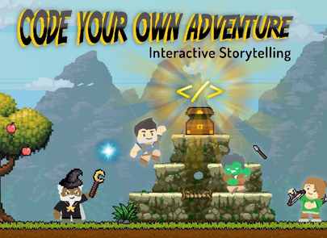

Code Your Own Adventure! (Black Rocket) Ages 8-11 and 11-14 Online
Watch as the characters in your imagination come to life in this unique course that blends classic storytelling with animation techniques and coding. Start with a concept, design the characters, and choose not just one ending, but many! Learn how to create your own text-based adventure games with variables, conditional logic, images, HTML, CSS, and Twine scripting syntax. Student projects will be available on a password protected Black Rocket website to share with friends and family.
REGISTER NOW

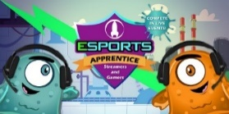

eSports Apprentice (Black Rocket) Ages 8-11 and 11-14 Online
Whether you want to be the next pro gamer, streamer, or gamecaster this course will teach you the basics to get started! No longer just a hobby, eSports is the fastest-growing career for the next generation. Over 400 million people watched YouTube videos and Twitch streams of video game competitions this year alone! In this course, students will develop game-play skills and compete using Black Rocket’s eSports games and apps, learn how to produce commentary for live tournaments, use professional streaming software, and most importantly practice online safety. Student recordings will be available on a password protected website to share with friends and family. Videos will not be broadcast publicly but will be shared with all students in the class.
REGISTER NOW

Online Classes, continued

Inventor’s League (Black Rocket) Ages 8-11 and 11-14 Online
Become an inventor of the future! Learn ‘rapid prototyping’ and problem solving as you conceptualize and design a product to solve a critical global issue. Each day begins with inspirational profiles of young inventors, such as the eleven-year-old who coded a robot to find victims of natural disasters. Next, research a problem to tackle in medicine, architecture, the environment, or a topic of your choosing. Once your vision is complete, learn how to draft 2D designs, create 3D models, and develop a website to pitch your ideas to the class. Student projects will be available on a password protected Black Rocket website to share with friends and family. Students will work in pairs or teams for most of the program.
REGISTER NOW

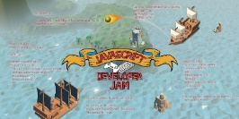

JavaScript Developer Jam (Black Rocket) Ages 8-11 and 11-14 Online
Learn programming tools so powerful they seem like magic! Start off by learning an array of core programming concepts with JavaScript by experimenting in a series of digital challenges. Start with programming your first animated memes, then tackle more advanced skills such as interactive 3D experiences and game creation. Projects will be available on a password protected Black Rocket website to share with friends and family. Students will work in pairs or teams for most of the program.
REGISTER NOW

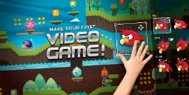

Make Your First Video Game! (Black Rocket) Ages 8-11 and 11-14 Online
If you love playing video games, this is the camp for you! Make your first video game in this one-of-a-kind class that shows you the keys to designing your first 2D platformer game. Conceptualization, play experience, challenge levels, graphics, sounds, and simple coding are just some of the concepts that we’ll explore. No prior experience necessary, just a desire to have fun. Student created games will be available on a password protected Black Rocket website to share with friends and family.
REGISTER NOW

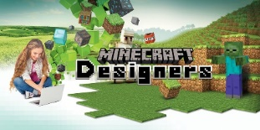

Minecraft Designers (Black Rocket) Ages 8-11 and 11-14 Online
If you love the game Minecraft, and always wanted to design your own world, this class is for you! Learn how to create a custom map, the basics of creating 3D models using a new software to design your very own objects, how to build with Redstone and Command blocks, and create custom textures for you to import at home or share with friends. Students must have a Java version of Minecraft. Tablet, phone, and game console versions of Minecraft are not compatible. Parent email address is required to use 3D modeling software. Students will work in pairs or teams for most of the program. Returning students can create more advanced projects that build on previous years.
REGISTER NOW

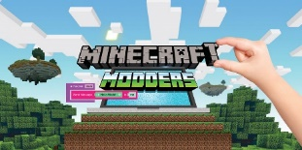

Minecraft Modders (Black Rocket) Ages 8-11 and 11-14 Online
Use your favorite game to learn the basics of modding and foundations of programming. Learn scripting and logic statements as you create your first mods! Introductory coding will also be taught through a simulated environment inspired by Minecraft. Student projects will be available on a password protected Black Rocket website to share with friends and family. Students must own a Java version of Minecraft to take this class. Tablet, phone, and game console versions of Minecraft are not compatible. Returning students can create more advanced projects that build on previous years.
REGISTER NOW

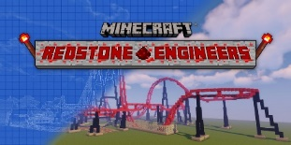

Minecraft Redstone Engineers (Black Rocket) Ages 8-11 and 11-14 Online
Take the next step beyond simply “playing” Minecraft and become a true Redstone engineer. Expand your Redstone knowledge by constructing your own carnival with a variety of mini-games, roller coasters, and attractions powered by Redstone. Learn how to use Command and Structure blocks to incorporate them into your builds. Activate your skills and take your Minecraft structures to the next level! Students must own a Java version of Minecraft to access their projects at home. Tablet, phone, and game console versions of Minecraft are not compatible.
REGISTER NOW

Online Classes, continued

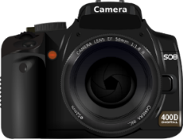

Photography 6th-12th Grade Online
Do you love taking photographs and are ready to learn more about the art form? Study with a professional photographer and learn the basics of lighting, composition, and camera settings. During this fun, hands-on class, we will explore different types of photography by studying the work of legendary photographers and exploring their techniques. Each session will include instruction, examples, and hands-on photo assignments. Practice taking portraits, landscapes, still life, street photography, and more! Students will have time each class to work on their photo assignment and get feedback from the instructor. Student photographers will develop a photography portfolio that highlights their personal style. The following camera types will work in this class: Smart Phone, iPad, Point and shoot camera, DSLR camera, Mirrorless camera - ask if you have a question. This class is an online only class.
REGISTER NOW

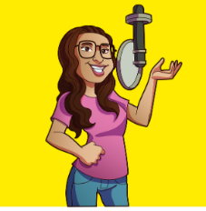

Podcasting Student Storytellers 6th-8th Grade Online

Have you ever wanted to create your own Podcast? In this fun workshop we will explore the power of audio storytelling and the world of Podcasting. Students will have the opportunity to produce their own short Podcast. Students will learn the basics of creating an audio story like interviewing techniques, how to use recording equipment and on-air presentation skills. Students should have basic computer skills, but no prior experience needed. Students will receive a Podcasting Manual with resources, tips, and release forms. The class is intended to be fun, hands on and informative. Students can focus on their area of interest, like writing, interviewing, voice work, or audio editing. Work in teams or on individual projects, self-directed lab for returning or advanced students.
REGISTER NOW

Online Classes, continued

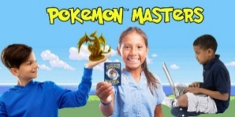

Pokemon Masters (Black Rocket) Ages 8-11 and 11-14 Online
Calling all boys and girls who want to be the designers of the future! In this class, if you can dream it, you can make it! Begin by creating your own digital Pokémon®-style custom playing card game. Progress onto designing action figures, jewelry, and toys in professional-level modeling software. Learn how to prepare a model for 3D printing and create a design portfolio to showcase your work! No prior experience is necessary and 3D designs will be available on a password protected Black Rocket website to share with friends and family.
REGISTER NOW

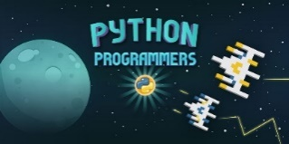

Python Programmers (Black Rocket) Ages 8-11 and 11-14 Online
Want to learn the world’s fastest-growing programming language favored by Google, NASA, YouTube, and the CIA? ​Learn how to code with Python to create engaging apps and games. Each lesson takes you step-by-step on a programming path that will let you challenge friends with fun content you create from start to finish!​ Students will work in pairs or teams for most of the program. Returning students can create more advanced projects that build on previous years​.
REGISTER NOW

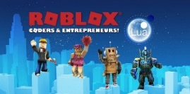

ROBLOX Coders & Entrepreneurs!(Black Rocket) Ages 8-11 and 11-14 Online
Discover how to code in the Lua language while playing and designing worlds in ROBLOX®, an online universe where you can create anything you dream of. This new class combines game design concepts, coding, and fun! Young entrepreneurs will also learn how to navigate Roblox’s fast-growing marketplace to publish their games. Student-created games will be available on a password protected Black Rocket website to share with friends and family.
REGISTER NOW

Online Classes, continued

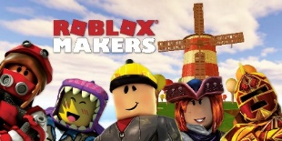

ROBLOX Makers (Black Rocket) Ages 8-11 and 11-14 Online
Unlock the power of ROBLOX® Studio, the world creation tool used by real-world ROBLOX® developers! Learn how to build 3D models and create an adventure in your ROBLOX® world. Bring characters to life with unique animations you design. Student-created projects will be available on a password protected Black Rocket website to share with friends and family.
REGISTER NOW

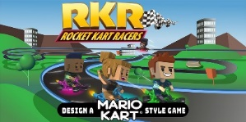

Rocket Kart Racers (Black Rocket) Ages 8-11 and 11-14 Online
On your marks, get set, create! Blast off in making your first 3D Mario Kart® and Crash Team Racing® style game! Design your own tracks and customize your karts and characters. Using a professional 3D game development software, students will combine their creations into their own kart racing game that they can play with friends and family at home. Students can participate in eSports League races against other schools across the country with a chance to have their tracks featured in the Black Rocket master build of the game! Student projects will be available on a password protected Black Rocket website to share with friends and family. Students will work in pairs or teams for most of the program.
REGISTER NOW

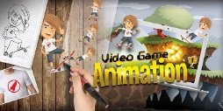

Video Game Animation (Black Rocket) Ages 8-11 and 12-14 Online
Take your game design to the next level by creating and animating your own character sprites, objects, and backgrounds. Start with a name, develop the character’s personality, signature moves, special powers, and a story line. Finish with a fully animated character to be used in future games. Students do not need any prior experience in game design, animation, or sketching. Student-created animations will be available on a password protected Black Rocket website to share with friends and family.
REGISTER NOW

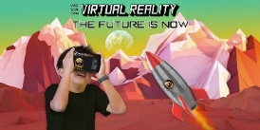

Virtual Reality (Black Rocket) Ages 8-11 and 11-14 Online
Embark on an EPIC adventure in virtual reality! In this cutting-edge class, you will learn the foundations of VR design by creating your own virtual worlds, exploring simulated environments, and crafting memorable 3D experiences. A cardboard VR headset is optional for this course. Students may order one from blackrocket.com/store, take the class without a headset, or use any headset that works with a mobile phone. VR projects will be available on a password protected Black Rocket website to share with friends and family.
REGISTER NOW

YouTube Content Creators (Black Rocket) Ages 8-11 and 11-14 Online
Find your voice and leave your mark on the world! Whether you are six or sixty, it’s time to start a career as the next YouTube star. Explore the variety of content and personalities that exist on YouTube and how to find your own niche. Learn the Dos and Don’ts of the platform and how to practice good digital citizenship. Develop your on-camera presence, your own channel branding, and professional editing skills. Take home a plan for launching your own channel with the content created in class! Student projects will be available on a password protected Black Rocket website to share with friends and family. Students work in pairs or teams for most of the program.
REGISTER NOW

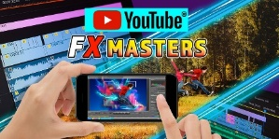

YouTube FX Masters (Black Rocket) Ages 8-11 and 11-14 Online
In the digital age, nothing is impossible! Become a master of illusion by learning the techniques used by Hollywood masters to create FX magic. Whether you want to enhance your YouTube videos or create a cool scene to amaze your friends; this class teaches the tools you need. Experiment with visual effects as you learn the dynamics of camera angles, editing, graphic layering, and sound effects. Then watch as your new creations take your channel content to the next level! Student projects are available on a password protected Black Rocket website to share with friends and family.
REGISTER NOW

Please note that updated class information is available on
our website at www.lcc.edu/seriousfun

